**Baku Higher Oil School**

**Process Automation Engineering Department**

**Programming in C**

**Laboratory 6 – Dynamic Memory Allocation**

**P.S** Add comment for each task; submit the file in LMS before the deadline.

1. Write a program that dynamically allocates an array of integers. The size of the array should be input from the keyboard. The elements of the array should be assigned values input from the keyboard. Print the values of the array. Next, reallocate the memory for the array to half of the current number of elements. Print the values remaining in the array to confirm that they match the first half of the values in the original array.
2. Create two different strings. Firstly, print each character (by pointer) and their address. Secondly, print first string till length * 3. See what happened. Thirdly, reallocate the infirst string and print its address. Finally, save the previous address of first string , print it and print all characters.
3. Create multiple simple functions (same return type and same number of parameters with same type). Then, create an array of pointer to these functions and use them.
4. Write a C program to add two matrix using pointers. (with Function)
5. Write a program to copy one array to another using pointers
6. Results?
   1. 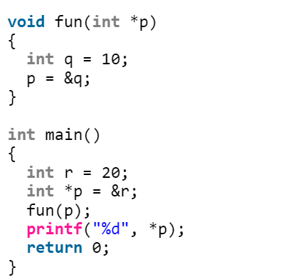
   2. 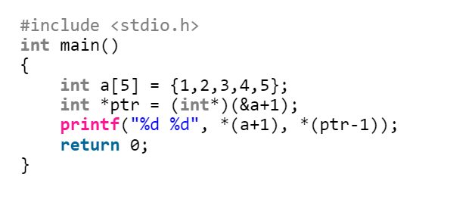
   3. 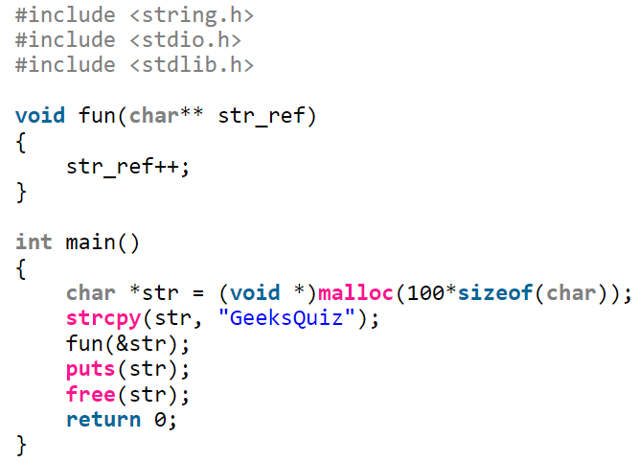
   4. 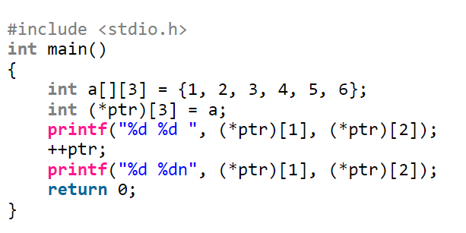
   5. 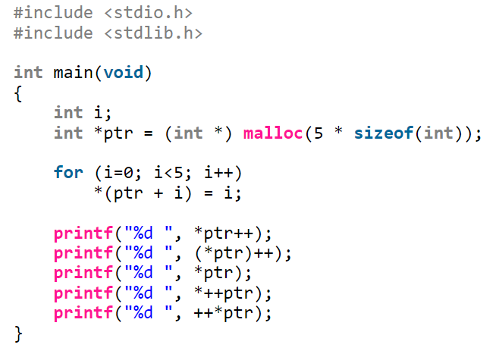
   6. Text, letter

      Description automatically generated
   7. 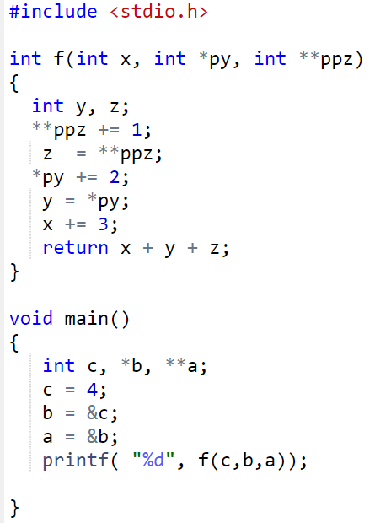
   8. Text

      Description automatically generated
   9. Assume x address is 2000:

